AUTOMATION PROJECT-NYKAA

**package** Testngpkg;

**import** java.awt.RenderingHints.Key;

**import** java.io.File;

**import** java.io.IOException;

**import** java.time.Duration;

**import** org.openqa.selenium.By;

**import** org.openqa.selenium.Keys;

**import** org.openqa.selenium.OutputType;

**import** org.openqa.selenium.TakesScreenshot;

**import** org.openqa.selenium.WebElement;

**import** org.openqa.selenium.WindowType;

**import** org.openqa.selenium.chrome.ChromeDriver;

**import** org.openqa.selenium.devtools.idealized.Javascript;

**import** org.openqa.selenium.interactions.Action;

**import** org.openqa.selenium.interactions.Actions;

**import** org.openqa.selenium.io.FileHandler;

**import** org.testng.annotations.BeforeMethod;

**import** org.testng.annotations.BeforeTest;

**import** org.testng.annotations.Test;

**public** **class** Automyntra

{

ChromeDriver dr;

@BeforeTest

**public** **void** nyknset()

{

dr=**new** ChromeDriver();

}

@BeforeMethod

**public** **void** urlnyk()

{

dr.get("https://www.nykaa.com/search/result/");

}

@Test

**public** **void** nyktest() **throws** IOException

{

WebElement fullname=dr.findElement(By.*xpath*("//*[@id=\"headerMenu\"]/div[2]/div[1]/div/form/input"));

fullname.clear();

fullname.sendKeys("skin"+Keys.***ENTER***);

dr.findElement(By.*xpath*("//*[@id=\"product-list-wrap\"]/div[1]/div/div[1]/a/div[2]/div[1]")).click();

dr.findElement(By.*xpath*("//*[@id=\"headerMenu\"]/div[1]/ul[2]/li/a")).click();

dr.navigate().to("https://www.nykaa.com/search/result/");

System.***out***.println("page 1 :" +dr.getTitle());

File screeshort=((TakesScreenshot)dr).getScreenshotAs(OutputType.***FILE***);

FileHandler.*copy*(screeshort, **new** File("D://ss.png"));

WebElement search = dr.findElement(By.*xpath*("//*[@id=\"headerMenu\"]/div[2]/div[1]/div/form/input"));

File src=search.getScreenshotAs(OutputType.***FILE***);

FileHandler.*copy*(src,**new** File("./Abc//singleelement.png"));

dr.switchTo().newWindow(WindowType.***TAB***);

dr.get("https://www.nykaa.com/search/result/");

dr.manage().window().maximize();

dr.manage().timeouts().implicitlyWait(Duration.*ofSeconds*(30));

WebElement click = dr.findElement(By.*xpath*("//*[@id=\"category\"]"));

Actions act=**new** Actions(dr);

act.moveToElement(click);

act.perform();

}

}

**Output**

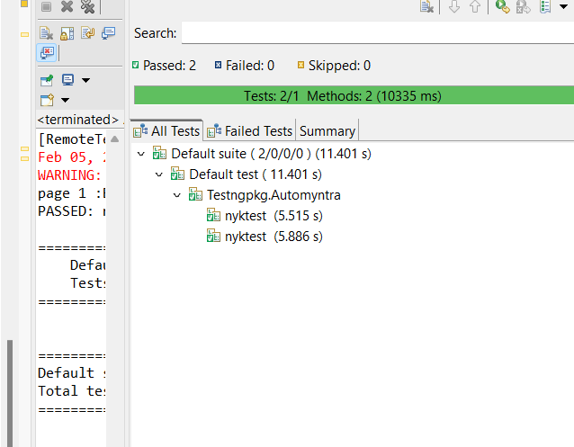

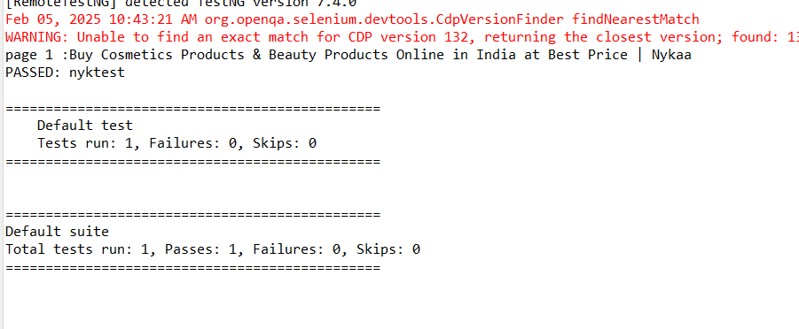

Screenshort of single web element



Screeshort of full page

